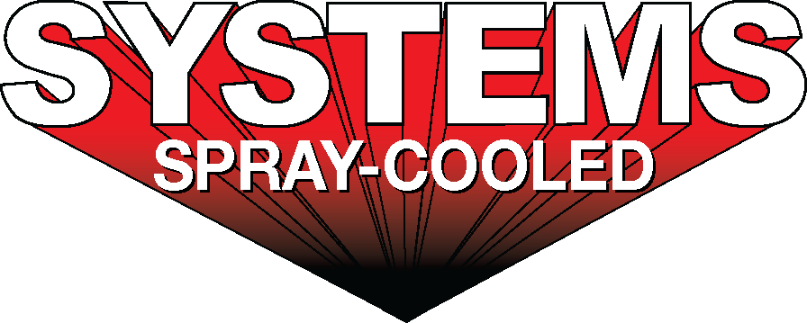

|  |  |
| --- | --- |
| ***For sales/reader service inquiries:***    Contact: Systems Spray-Cooled  885 Seven Oaks Blvd. Ste 910  Smyrna, TN 37167  +1-615-366-7772  E-mail [info@tsg.bz](mailto:info@tsg.bz) | ***For media inquiries:***  Contact: Caleb Fairres  The Systems Group  +1-870-862-1315  E-mail: [info@tsg.bz](mailto:info@tsg.bz) |

**Systems Spray-Cooled receives order from SMS group**

**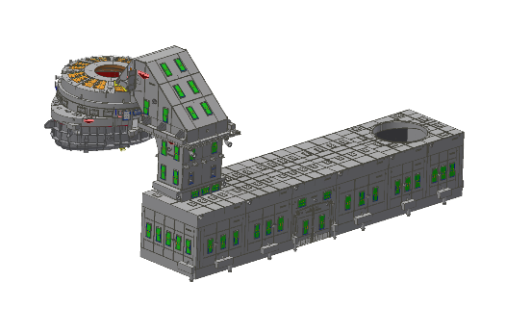*For Immediate Release, Nashville, TN*** ---- Systems Spray-Cooled of The Systems Group received an order from SMS group for the design and supply of Spray-Cooled™ equipment for SSAB’s new EAF project located in Oxelösund, Sweden. As part of SMS’s awarded contract, the SSAB project consists of (1) 190 M ton state-of-the-art AC furnace. The EAF will utilize Spray-Cooling for the upper shell, roof, and fume elbow as well as the Direct Evacuation Control System (DECS) consisting of a movable D1 downcomer duct and a panelized Drop-out Chamber (DOC).

The EAF roof is a gantry style roof with a steep cone hot face profile for optimization and extended lifetime. The D1 downcomer duct is hydraulically actuated on a fixed rail support system that allows for real-time air gap adjustment and swing clearance. The DOC is a panelized, self-supported design consisting of multiple sidewall and roof panel segments with an access door for cleanout.

SSAB’s decision to install Spray-Cooled™ equipment was based on the need for the safest and most reliable solution when considering long term maintenance costs.

For product information, go to https://www.spraycooled.com/; For general information, call Systems Spray-Cooled at 615-366-7772 or email info@spraycooled.com.