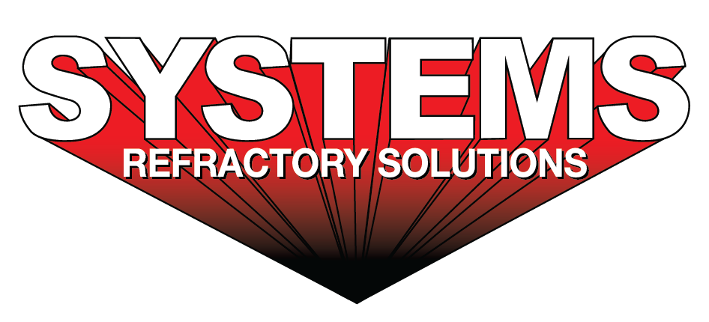
For sales/reader service inquiries:  Contact: Systems Refractory Solutions 0 County Rd 490  Hanceville, AL 35077  +1-724-513-5403  E-mail jsmitsky@tsg.bz | For media inquiries:  Contact: Grant Roberts  The Systems Group  +1-870-862-1315  E-mail: info@tsg.bz

Systems Refractory Solutions Announces Official Launch to Advance Refractory Maintenance Services in Steel Mills

For Immediate Release, Little Rock, AR ---- The Systems Group is proud to announce the official launch of a new business unit, Systems Refractory Solutions, a specialized provider of refractory maintenance services dedicated to the steel industry. The company will deliver high-quality, safety-focused refractory maintenance solutions designed to enhance reliability, extend equipment life, and reduce downtime at steel mills across the United States. Led by Josh Smitsky, with over 20 years in the refractory industry, and Mike Williams, with over 30 years in steel mill melt shops.

Systems Refractory Solutions builds on The Systems Group’s (TSG) long-standing tradition of engineered solutions for the steel industry — a legacy of over 50 years of industry expertise, productivity improvements, and safety innovation.

“Our mission at Systems Refractory Solutions is to provide steel mills with refractory maintenance services that not only meet industry standards, but set new benchmarks in operational efficiency and safety,” said Kyle Morgan, President of The Systems Group. “We are excited to bring a focused, expert team to support critical refractory systems — minimizing downtime and helping our customers succeed in an increasingly competitive landscape. We aim to replace the dime a dozen refractory maintenance services with a new standard in service, reliability, and safety.”

Systems Refractory Solutions offers a comprehensive suite of refractory maintenance services, including:
- Routine refractory inspections and condition assessments, specializing in reheat furnaces
- 24/7 Emergency Refractory Repair Services
- Maintenance Planning and Lifecycle Support
- Refractory Relining and Refurbishment
- Turnkey Shutdown Projects
- Brick installation
- Plastics - Ram or Gun
- Gunite Installation
- Shotcrete Installation
- Castable Pumping and Forming
- Ceramic Fiber Installation
- Ceramic fiber pumpable on running units to cool hotspots to reduce downtime
- Precast Shape Installation
- Prefabricated Fiber Lined Units
- Ladle Relining
- Furnace Door Lining Repairs
- On-site technical expertise from trained refractory specialists

By concentrating exclusively on refractory maintenance, the company aims to solve the unique high-temperature wear challenges faced by melt shops, furnaces, ladles, tunnel & reheat furnaces and other critical components in steel production facilities.

The launch of Systems Refractory Solutions reflects an increasing demand within the metals industry for dedicated refractory expertise — an area that is critical to the uninterrupted operation of steelmaking infrastructure. With deep experience in steel mill services and engineered solutions, Systems Refractory Solutions is positioned to become a trusted partner to operations seeking maximum uptime and cost-effective refractory lifecycle management.

About Systems Refractory Solutions
Systems Refractory Solutions is a specialized service provider focused on refractory maintenance for steel mills. Our team combines industry knowledge, skilled execution, and a safety-first approach to support uptime and performance in demanding industrial environments.

About The Systems Group (TSG)
The Systems Group is a diverse group of privately held companies offering engineered solutions to the steel industry with over 50 years of experience supporting maintenance, fabrication, construction, and plant services. TSG’s focus on productivity and safety has helped the steel industry improve operations worldwide.

For product information, go to https://refractory.tsg.bz/. For general information, contact The Systems Group at 870-862-1315 (U.S./Canada); email info@tsg.bz web www.tsg.bz.

