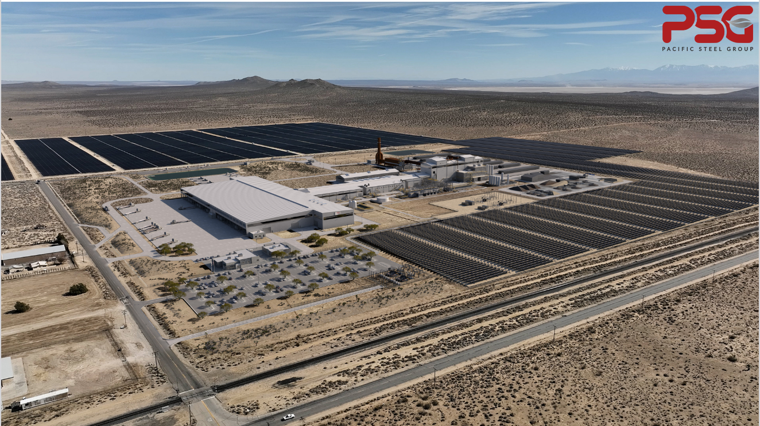

Press Release: Systems Spray-Cooled™ receives order from Pacific Steel Group
February 24, 2026 |The Systems Group
Nashville, TN – Systems Spray-Cooled™ LLC received an order from Pacific Steel Group for the design and supply of Spray-Cooled™ equipment for their new EAF project located in Mojave, CA.
As part of the recently awarded contract, the new PSG steel plant will consist of (1) 43 short ton AC EAF Endless Charging System. The EAF will utilize Spray-Cooling for the upper shell and the 5.1m cantilever style roof. As part of the scope, SSC will provide engineering for the furnace supply and return water piping.
PSG’s decision to install Spray-Cooled™ equipment was based on the need for the safest and most reliable and energy efficient solution when considering long term maintenance and operational costs.
For product information, go to https://www.spraycooled.com/; For general information, call Systems Spray-Cooled at 615-366-7772 or email info@spraycooled.com.
# # #

