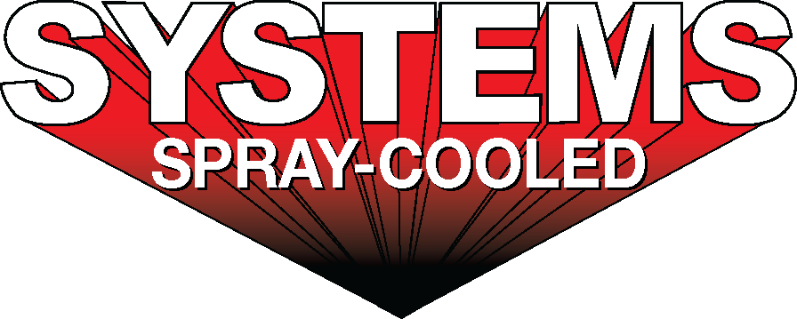

|  |  |
| --- | --- |
| ***For sales/reader service inquiries:***    Contact: The Systems Group  214 N Washington Ave, Ste. 700  El Dorado, AR 71730  (870) 862-1315  E-mail [info@tsg.bz](mailto:info@tsg.bz) | ***For media inquiries:***  Contact: Kyle Morgan  The Systems Group  (870) 882-1500  E-mail: [kmorgan@tsg.bz](mailto:kmorgan@tsg.bz) |

**Systems Spray-Cooled receives order from Nucor Steel West Virginia**

***For Immediate Release***, March, 2023 Nashville, TN *–*

Nucor Steel Corporation has placed an order for new Electric Arc Furnace (EAF) equipment with Systems Spray-Cooled of The Systems Group for its greenfield sheet mill located in Mason County, WV.  The Spray-Cooled™ equipment will cover 100% of Nucor Steel’s furnace cooling needs and will include the furnace sidewall, roof, and elbow for (2) new EAF’s.  The EAF roof will be a 3-point gantry design. The elbow incorporates a new integrated drain design that eliminates bolted connections for quicker change outs. The EAF sidewall incorporates a unique proprietary ‘sloped’ hot face profile that includes integrated ‘bump-outs’ to help protect the burners and refractory bricks, and reduce scrap jams at the slag door opening area.

In addition to the Spray-Cooled™ equipment, Systems Contracting will also be supplying the piping throughout the entire meltshop.

Nucor Steel’s decision to install Spray-Cooled™ equipment was based on the need for the safest, most environmentally friendly, lowest cost option (supply and maintenance) along with the extended life and performance for water-cooled equipment.

For product information, go to https://spraycooled.tsg.bz/. For general information, contact The Systems Group at 870-862-1315 (U.S./Canada); email [info@tsg.bz](mailto:info@tsg.bz) web [www.tsg.bz](http://www.tsg.bz).

# # #